



Essay / Assignment Title: Machine Learning Meets Term Life Insurance: Targeting High-Value Customers

Programme title:

Name:

Year:

CONTENTS

Contents
CONTENTS 2
LIST OF FIGURES 6
LIST OF TABLES 7
INTRODUCTION 9
1.1 HashSysTech Insurance's History 9
1.2 Project Greenlight's Goal 9
1.3 The Report's Objective 9
CHAPTER ONE: UNDERSTANDING THE DATASET 10
2.1 HashSysTech Insurance Dataset Overview 10
2.2 Important Elements and the Aim Variable 10
The dataset contains term life insurance conversion status as a dependent variable necessary for the predictive model, which aims to predict customer conversion based on the presented features above. The status could either accept or reject the offer. 10
2.3 First loading and inspecting the data 10
Data Inspection Steps 11
Insights 11
CHAPTER TWO: DATA EXPLORATION AND PREPARATION 14
3.1 Data Exploration 14
3. 1. 1 Basic Summary of Numerical Qualities 14
3.1.2 Frequency Analysis of Categorical Features 14
3.1.3 Summary of Findings 15
3.2 Handling Missing Values and Outliers 15
3. 2. 1 Identification of None/Absent Values 15
3. 2. 2 Approaches to Deal with the Problem of Data Missing 16
3. 2. 3 Detection and Treatment of Outliers 16
3. 2. 4 Justification of Methods Used 17
3. 3 Data Visualization 17
3. 3. 1 Visualizations of Numerical and Categorical Features 17
3. 3. 2 Analysis of Feature Relation to the Target Variable 20
3. 3. 3 Insights from Visualizations 23
CHAPTER THREE: MODEL SELECTION AND TRAINING 24
In this section, I explained how to select the correct algorithm for converting customers from term life insurance using the A. I. empowered preflight and format used in model tuning, learning, and realizing different algorithms, testing their relevance, and how data split occurs proportionally to the target variable. 24
4.1 Model Selection 24
4.1.1 Overview of Machine Learning Algorithms 24
The aim was to minimize those model performance measures and maximize the final algorithms' interpretability and predictiveness. At the same time, Random Forest is less interpretable than Lasso but capable of generating high-level models and processing feature interactions. 25
4.2 Data Splitting 25
4.2.1 Strategy for Data Splitting 25
When developing benchmark models, one must split the dataset into a training and test set. Also, the training set consists of data points that help find a suitable model, while the testing set checks how such a model performs over never-seen data. This is the best method of ensuring we see a model capable of performing how it was designed when exposed to other data on which it has yet to be trained. Generally, 80% of the datasets are used for training, while the remaining 20% is used for testing and validation. 25
4.2.2 Maintaining Target Variable Proportions (Stratification) 25
4.2.3 Summary of Data Splitting Process 25
Using a stratified sampling strategy was appropriate in training and testing processes to minimize bias and improve the model's accuracy on unseen data, thus improving the overall evaluation. 26
4.3 Model Training 26
4.3.1 Random Forest Model Training 26
4.3.2 Logistic Regression Model Training 26
4.3.3 Summary of Model Training 27
CHAPTER FOUR: MODEL INTERPRETATION AND EVALUATION 28
5.1 Model Interpretation 28
5.1.1 Feature Importance Analysis 28
Using the Random Forest algorithm, one can determine potential influencing factors of customer conversion, especially regarding selling term life insurance, including the interaction duration, number of dials made, and the customer's age. These research results are consistent with domain knowledge and focus on customer engagement measures' influences on sales results. 28
5.1.2 Explanation of Model Decision-Making Process 28
Random forest is one of the decision tree-based learning methods used in the insurance business to predict future customer behavior. Every tree has a bootstrapping test employing an independent data sampler. It recognizes the perpetual features while rendering choices to avoid overfitting the raw outcome and improve the crispness of the result. 28
5.1.3 Key Findings and Insights 28
It also focuses on customer touch points such as last contact and total calls to demonstrate how conversion probability can be influenced, meaning that customer touch points are critical determinants of conversion rates. It also emphasizes segmentation, emphasizing issues such as the age factor. 28
5.2 Model Evaluation 28
5.2.1 Evaluation Metrics (Accuracy, Precision, Recall, F1-score) 28
From the confusion matrix, it is found that the Logistic Regression model has 90% accuracy, 92% ‘no’ precision, and 98% ‘no’ recall but only a 33% ‘yes’ recall, meaning that it does not recognize converting customers as the Random Forest model does. 29
5.2.2 Hyperparameter Tuning and Optimization 29
5.2.3 Final Model Evaluation and Performance Summary 29
CONCLUDING REMARKS 30
6.1 Recap of Key Findings 30
6.2 Recommendations 30
BIBLIOGRAPHY 31
APPENDIX 32
Appendix A: Access to Python Code and Analysis 32

LIST OF FIGURES

Figure 1: Jupyter Notebook Code and Output: Data Loading and Initial Inspection 10
Figure 2: Jupyter Notebook Code and Output: Dataset Information 11
Figure 3: Jupyter Notebook Code and Output: Duplicate Entry Check 11
Figure 4: Jupyter Notebook Code and Output: Descriptive Statistics for Numerical Features 13
Figure 5: Jupyter Notebook Code and Output: Frequency Counts for Categorical Features 14
Figure 6: Jupyter Notebook Code and Output: Missing Values Check 15
Figure 7: Jupyter Notebook Code and Output: Outlier Detection and Handling 16
Figure 8: Jupyter Notebook Code and Output: Data Visualization 17
Figure 9: Histograms of Numerical Features 17
Figure 10: Distribution of Job and Marital Status 18
Figure 11: Distribution of education_qual and call_type 18
Figure 12: Distribution of Mon and Prev_outcome 19
Figure 13: Distribution of Target Variable (y) 19
Figure 14: Conversion Rates by Job 20
Figure 15: Conversion Rates by Job and Marital Status 20
Figure 16: Conversion Rates by Education Qual and Call Type 21
Figure 17: Conversion Rates by Mon and Prev Outcome 21
Figure 18: Conversion rates by Target Variable (y) 22
Figure 19: Jupyter Notebook Code and Output: Data Splitting and Class Distribution 24
Figure 20: Jupyter Notebook Code and Output: Random Forest Model Evaluation 25
Figure 21: Jupyter Notebook Code and Output: Logistic Regression Model Evaluation 26

LIST OF TABLES

Table 1: Data Description of Missing Values in Each Column 11
Table 2: Descriptive Statistics for Numerical Features 12
Table 3: Random Forest Classification Report 27
Table 4: Logistic Regression Classification Report 28

Statement of compliance with academic ethics and the avoidance of plagiarism

I honestly declare that this dissertation is entirely my own work and none of its part has been copied from printed or electronic sources, translated from foreign sources and reproduced from essays of other researchers or students. Wherever I have been based on ideas or other people texts I clearly declare it through the good use of references following academic ethics.
(In the case that is proved that part of the essay does not constitute an original work, but a copy of an already published essay or from another source, the student will be expelled permanently from the postgraduate program).

Name and Surname (Capital letters):

.......................................................................................................................................

Date: ........................./........../.........

INTRODUCTION

1.1 HashSysTech Insurance's History
HashSysTech is an insurance company that delivers services and products specific to the market's needs. The firm has applied innovation in service delivery and is a customer-oriented firm that applies analytics to operations and communication techniques.

1.2 Project Greenlight's Goal
The organization, HashSysTech Insurance, is undertaking Project Greenlight to enhance its telemarketing for term life insurance. The purpose is to assess leads that can be used to identify customers for marketing and minimize expenses (Lemmens, A. and Gupta, S., 2020). The idea is to build a predictive model to help pinpoint the customers’ propensity to purchase term life insurance products and thus market directly to clients most likely to buy.

1.3 The Report's Objective
This report clearly describes how the data investigation and analysis are carried out, together with the stage of machine learning (Lavin, A., Gilligan-Lee, C.M., Visnjic, A., Ganju, S., Newman, D., Ganguly, S., Lange, D., Baydin, A.G., Sharma, A., Gibson, A. and Zheng, S., 2022.) useful in assisting Project Greenlight. These include data comprehension, feature analysis, and customer conversion rates. They also cover choosing the appropriate machine learning models to help make proper estimations of consumers’ behavior. The last objective is to advice on HashSysTech Insurance’s marketing plans.

CHAPTER ONE: UNDERSTANDING THE DATASET

2.1 HashSysTech Insurance Dataset Overview
Presently, HashSysTech Insurance has amassed a database containing customer information better to grasp the customers' behavior regarding term life insurance. In particular, this information helps to build models for such activity in developing markets, select potential clients, and determine factors that would impact the conversion factor. Other information gathered is personal information, past communication, and prior usage of the insurance services. This data is crucial to market their product to possible clients effectively.

2.2 Important Elements and the Aim Variable
The dataset contains several features which are crucial in determining the customer conversion rate (Lalwani, P., Mishra, M.K., Chadha, J.S. and Sethi, P., 2022). These features include:
- Demographic Information: The demographic characteristics of the customers include age, gender, marital status, and income level giving information on customers’ personal lives.
- Customer Interaction History: Past conversations with the customers regarding HashSysTech, which determines the number of times contact has been made and in what capacity, thus can be used to determine how much the customers are interactive.
- Product Details: Information on the types and numbers of insurance products that have been bought by the customer earlier, which can give an insight into the insurance requirements of that customer.
- Engagement Metrics: Measures such as the talk-time, which gives the actual time that was spent on the possible sales calls and the response rates common from telemarketing advertisements.

The dataset contains term life insurance conversion status as a dependent variable necessary for the predictive model, which aims to predict customer conversion based on the presented features above. The status could either accept or reject the offer.

2.3 First loading and inspecting the data
The first and primitive step of data analysis is to transfer the data into the correct data processing tool, such as Python or Pandas, for proper and clean analysis (Gupta, P., 2021). Some of the steps in the data cleansing process are Data acquisition, which ensures that the data collected is clean, and Data screening, which verifies the accuracy of the data input.

Data Inspection Steps
- Data Integrity Checks: The first steps included simple data audits, which provided general checks for any inconsistencies in the data by ensuring that there were no missing fields, incorrect data types, or duplicated cases.
- Data Summary: To create an overview of the dataset, the total number of observations and features were computed and presented in the summary.
- Basic Descriptive Statistics: The first step towards data exploration was to obtain basic measures of centrality for numerical features and a count of categories for categorical features in order to familiarize with the data.

Insights
The data inspection revealed no missing values and identified several key insights:
- Numerical Features: It also reveals all ages and various call durations, which is a sign of various levels of customer involvement.
- Categorical Features: Employees in routine and technical-clerical occupations occupy most of the jobs; the majority of them are married. The majority of the contacts were made through the use of cellular phones.
- Target Variable Imbalance: The distribution of the target variable shows that most customers do not subscribe to the company’s products.
- Duplicates: Six entries were found duplicated and should be excluded:
In the study, the report described how they enhanced customer conversion prediction by focusing on duplicity, shifting data, and using graphical presentations to balance the models and improve their accuracy (Elahe, M.F., Jin, M. and Zeng, P., 2021).
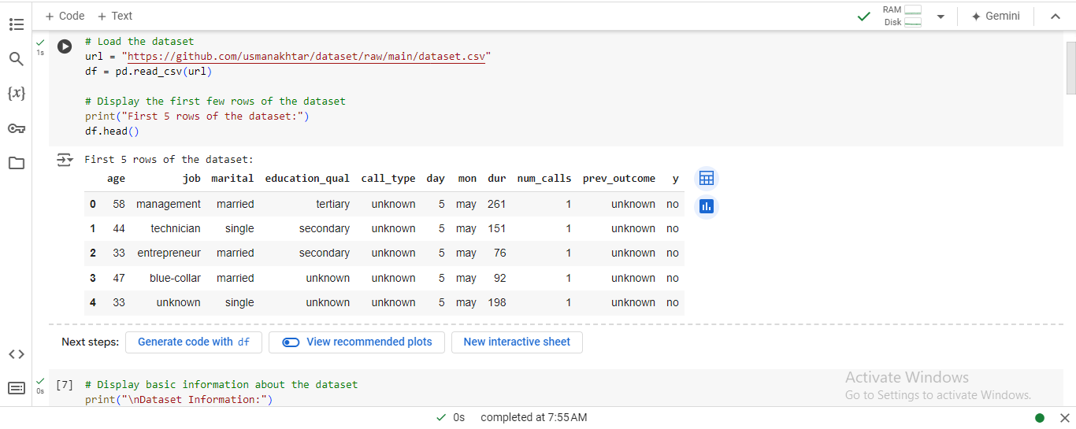
Figure 1: Jupyter Notebook Code and Output: Data Loading and Initial Inspection
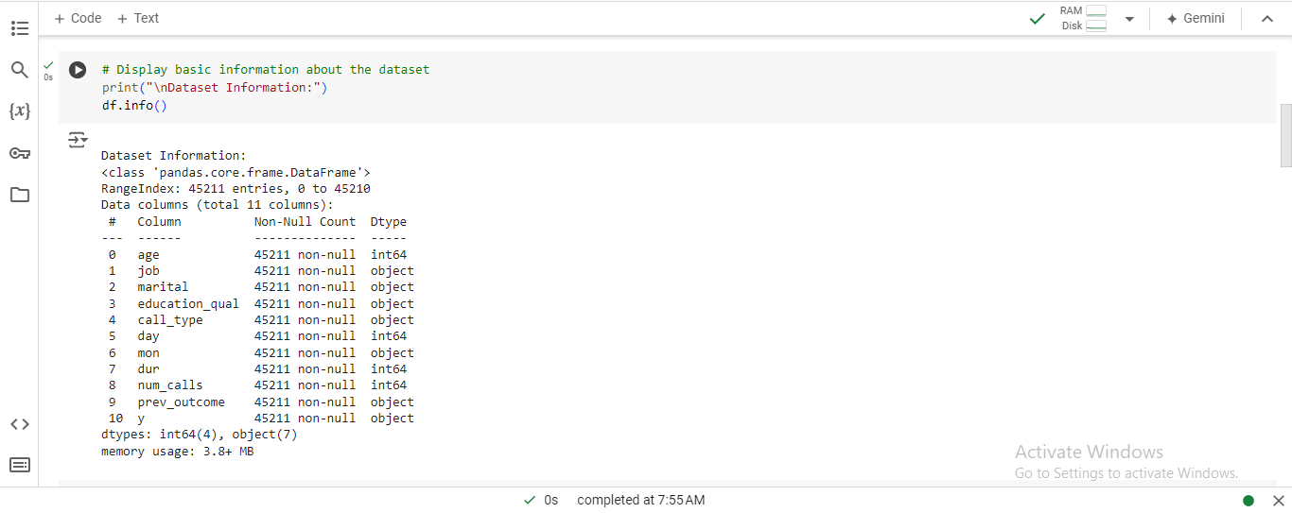
Figure 2: Jupyter Notebook Code and Output: Dataset Information

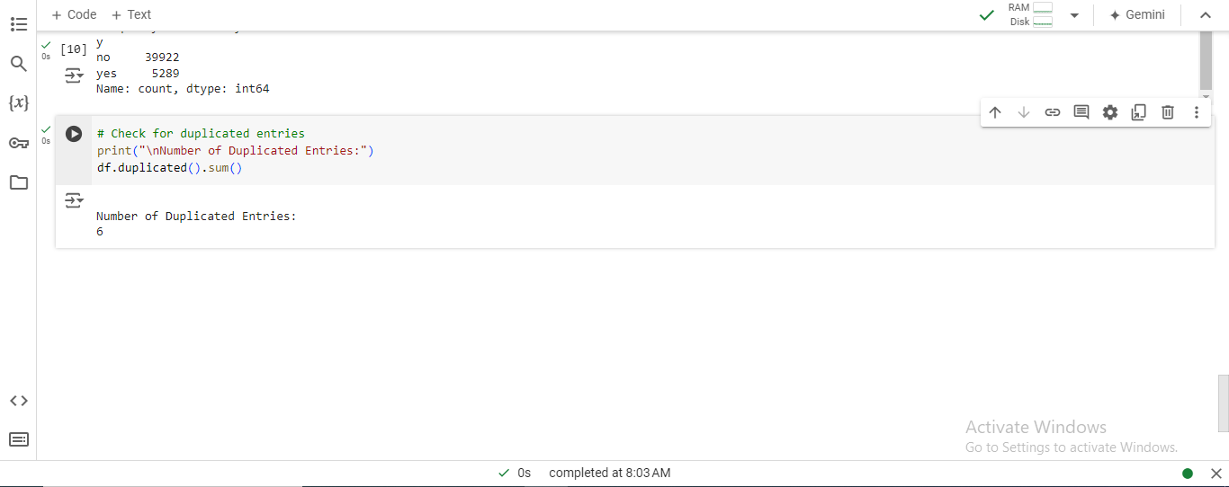
Figure 3: Jupyter Notebook Code and Output: Duplicate Entry Check
Table 1: Data Description of Missing Values in Each Column
Column | Count
Age | 0
Job | 0
Marital | 0
Education_qual | 0
Call_type | 0
Day | 0
Mon | 0
Dur | 0
Num_calls | 0
Prev_outcome | 0
Y | 0

Table 2: Descriptive Statistics for Numerical Features
Feature | Count | Mean | Std Dev | Min | 25% | 50% | 75% | Max
age | 45,211 | 40.94 | 10.62 | 18 | 33 | 39 | 48 | 95
day | 45,211 | 15.81 | 8.32 | 1 | 8 | 16 | 21 | 31
dur | 45,211 | 258.16 | 257.53 | 0 | 103 | 180 | 393 | 4918
num_calls | 45,211 | 2.76 | 3.10 | 1 | 1 | 2 | 3 | 63

In this manner, the robustness of the last dataset was established, and the group proceeded to develop data exploration and preparation activities that would help to prepare the dataset for model development.

CHAPTER TWO: DATA EXPLORATION AND PREPARATION

This section covers the process of exploratory data analysis and data wrangling where the nature of the dataset is learned and it is transformed in the right format for modeling (Molin, S., 2021).

3.1 Data Exploration
The exploratory data analysis helps in getting an insight into the features in the data set, both numerical and categorical, and looks for various patterns if any, and anomalies (Magdum, R., 2022).

3. 1. 1 Basic Summary of Numerical Qualities
The data analysis found that the company has a sizeable number of customers, eliminating the notion of having a small market. It confirms clients’ heterogeneity and shows that though the average call stay is short; the variability is high, pointing to a mixed nature of clients’ interaction there. The calls were on different counts because of the other campaigns, and such customer response reveals interaction activity.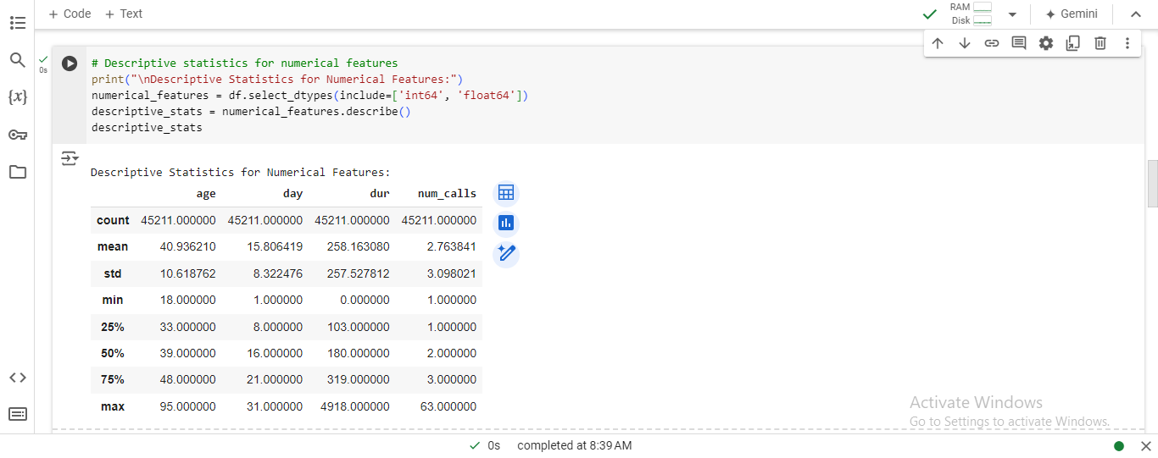
Figure 4: Jupyter Notebook Code and Output: Descriptive Statistics for Numerical Features

3.1.2 Frequency Analysis of Categorical Features
Based on the categorical features, it was found that most customers are from the working class, many of them from blue-collar jobs or managerial positions. Other demographic variables included gender and marital status, where married people were also found in the majority. The type of customer contact with the highest response rate was ‘cellular; this means this method was proper or preferred in reaching customers. This analysis makes it possible to discover the most critical category of customers and the main ways of communicating with them.
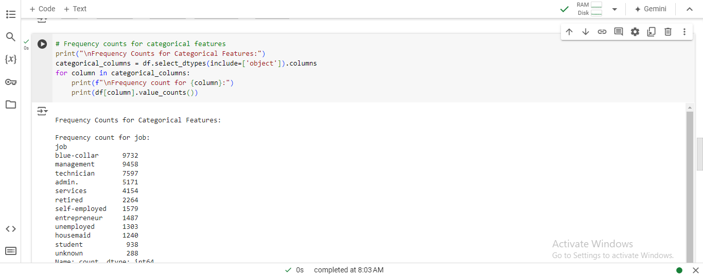
Figure 5: Jupyter Notebook Code and Output: Frequency Counts for Categorical Features

3.1.3 Summary of Findings
The initial exploration highlighted several key findings:
- Numerical Features: The most important aspect here is that the customers’ age and call duration vary greatly, which might also affect the conversion rates.
- Categorical Features: Some of them, such as ‘job’ or ‘marital status,’ are rather dominated by particular types of users, which may be valuable segments in the context of a targeted marketing approach.
- Data Quality: In terms of data preprocessing, it is also fortunate that there are no missing values in the dataset.
These results provide more grounds for further investigation, making it possible to control for outliers and use graphics as an additional tool for visualizing the data structure.

3.2 Handling Missing Values and Outliers
This section is devoted to dealing with the missing data and outliers when present in the dataset for greater consistency.

3. 2. 1 Identification of None/Absent Values
The study was conducted on the data set provided, and no null values in any of the columns were indicated among the outcomes. This means that the data is sufficient, and there will be no need to input more records from the data sources. However, other data quality characteristics, such as outliers, should be considered.
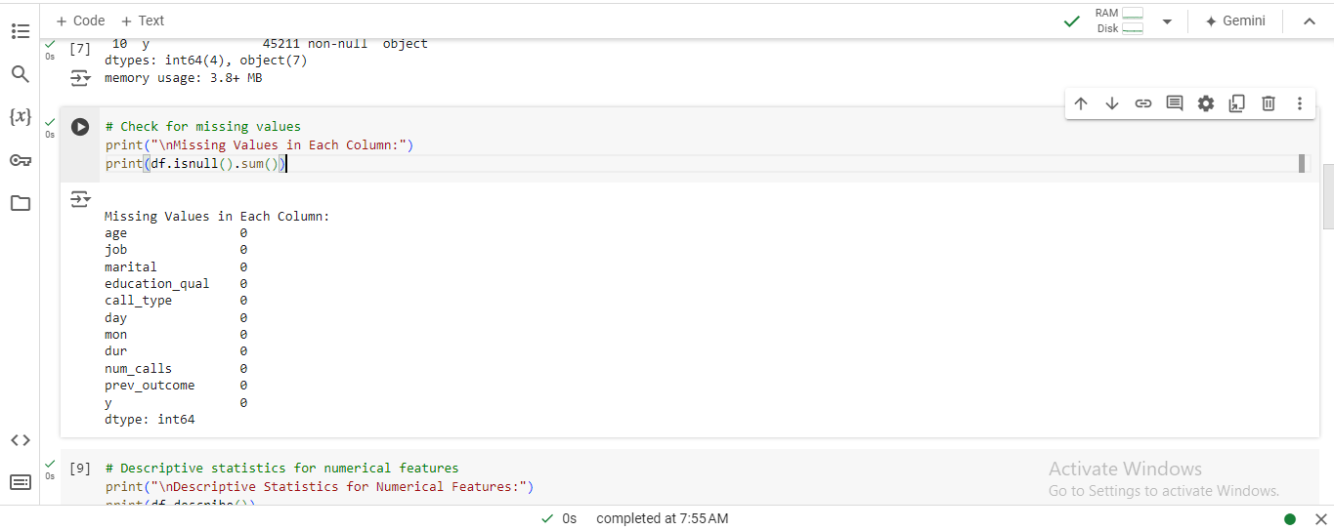
Figure 6: Jupyter Notebook Code and Output: Missing Values Check

3. 2. 2 Approaches to Deal with the Problem of Data Missing
Since there are no missing values observed in the dataset, no type of imputation, i.e., data filling, is required. Nevertheless, it is still possible to have numerous incorrect data entries, which is something one has to keep in mind.

3. 2. 3 Detection and Treatment of Outliers
Using the z-score method, several numerical features showed outliers, and the values were excluded. Specifically, the age, dur, and num_calls columns showed a substantial number of outliers: Specifically, the age, dur, and num_calls columns showed a substantial number of outliers:
- age: 381 outliers
- dur: 963 outliers
- num_calls: 840 outliers
These are cases that can worsen or improve the performance of the model if they are not brought into normality. In the case of outliers, the values have been dealt with using the Interquartile Range (IQR) method in a way to restrict the values at a reasonable level.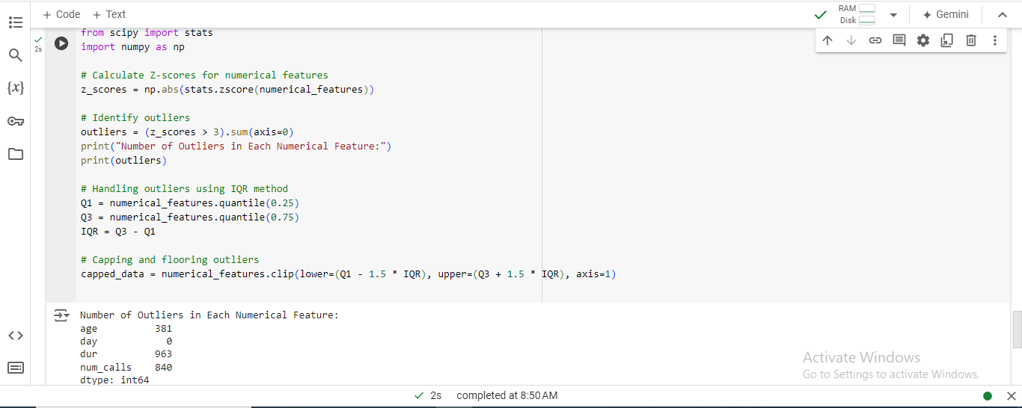
Figure 7: Jupyter Notebook Code and Output: Outlier Detection and Handling

3. 2. 4 Justification of Methods Used
Evaluations of sources of variation: The IQR method is used to eliminate outliers because it can restrict large values other than eliminating the correct value while limiting the form of the data set (Dallah, D. and Sulieman, H., 2022). This approach helps erase data and remove values that can distort the model and are out of range.

3. 3 Data Visualization
Exploratory visualization exercises were used in order to identify or discover patterns, trends, as well as relationships between features.

3. 3. 1 Visualizations of Numerical and Categorical Features
Histograms and box plots were used to build statistical summaries, with the goal of identifying skewness and outliers in numerical features. Frequency distribution histograms were applied to categorical data to visualize the distribution of the data, the number of observations within the first few topmost categories, and to detect skewness and outliers.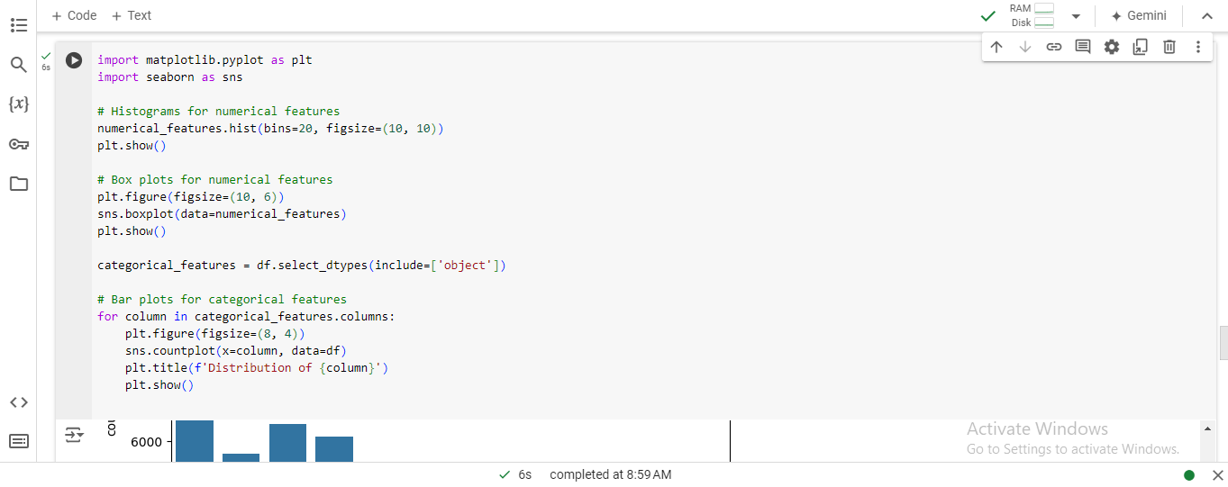
Figure 8: Jupyter Notebook Code and Output: Data Visualization
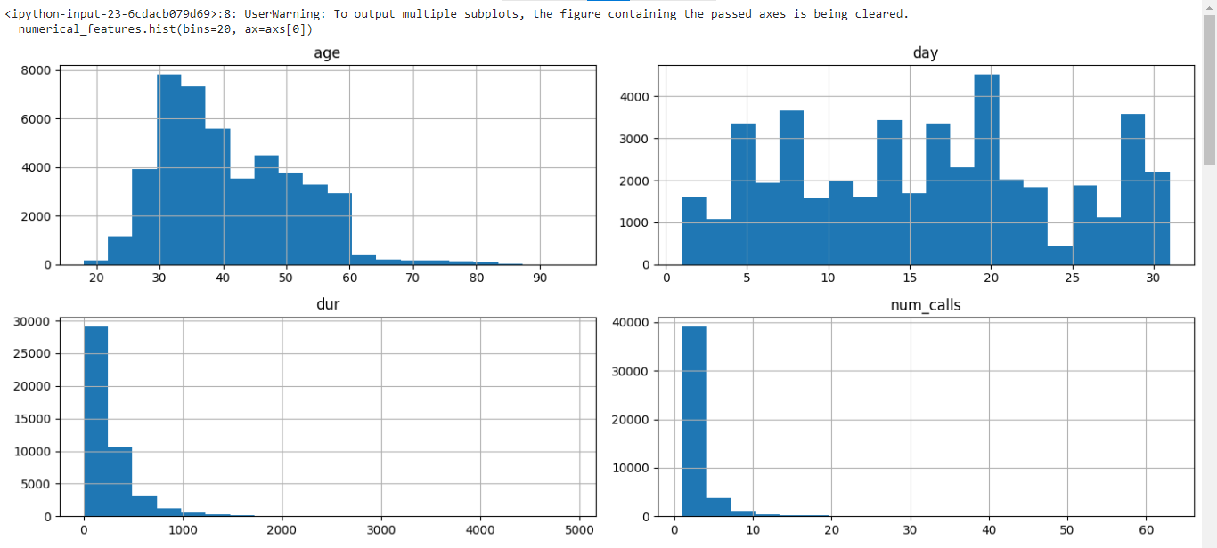
Figure 9: Histograms of Numerical Features
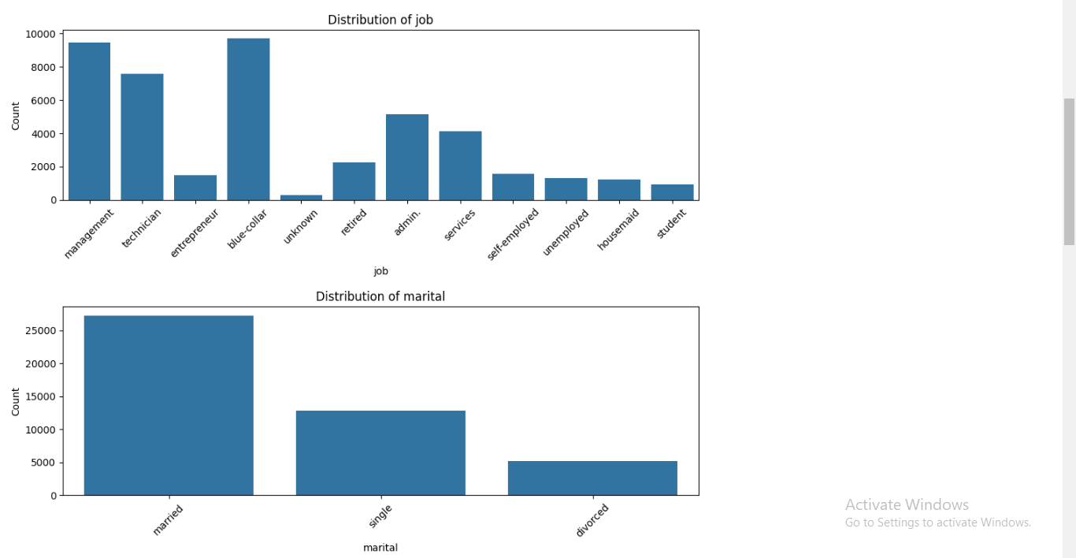
Figure 10: Distribution of Job and Marital Status
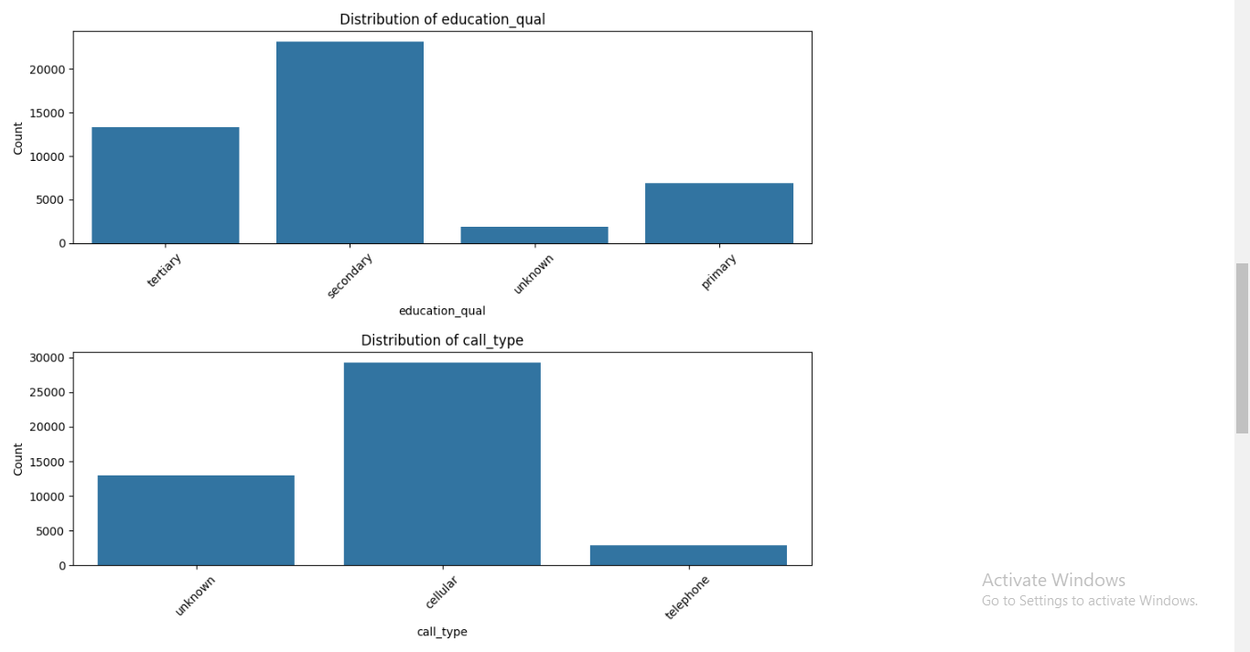
Figure 11: Distribution of education_qual and call_type
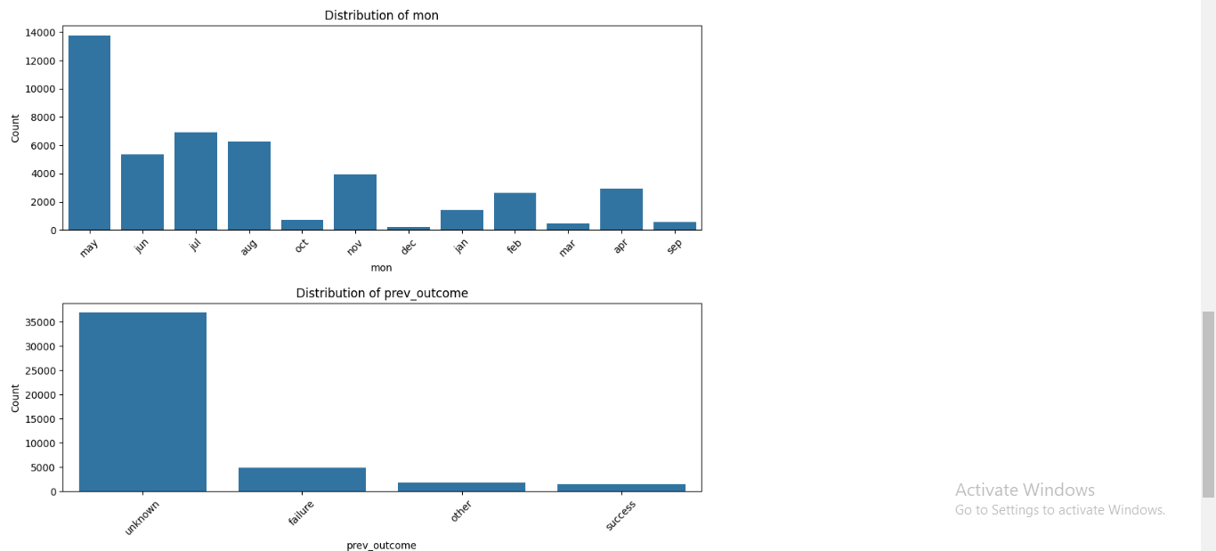
Figure 12: Distribution of Mon and Prev_outcome
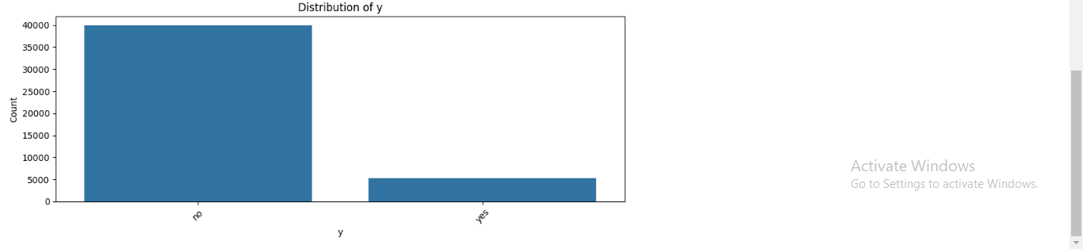
Figure 13: Distribution of Target Variable (y)

3. 3. 2 Analysis of Feature Relation to the Target Variable
Bar plots investigated the correlation between features and the target variable and count plots for a better understanding of the data distributions. In addition, these displays provided:
- Guidance on which aspects most immediately relate to the propensity for conversion.
- Guidance for focused marketing and modeling efforts.
- Feature selection.
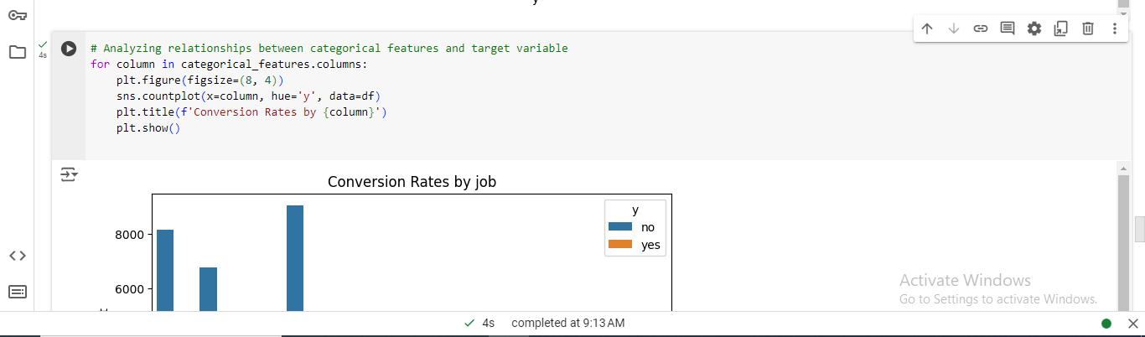
Figure 14: Conversion Rates by Job
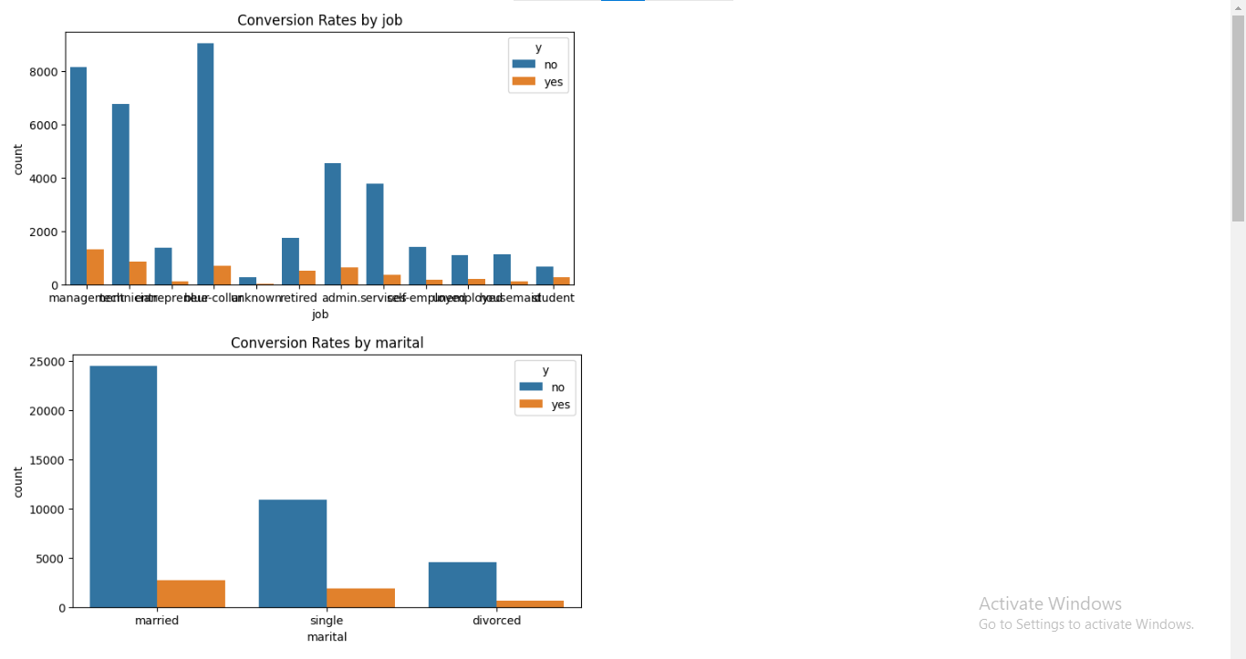
Figure 15: Conversion Rates by Job and Marital Status
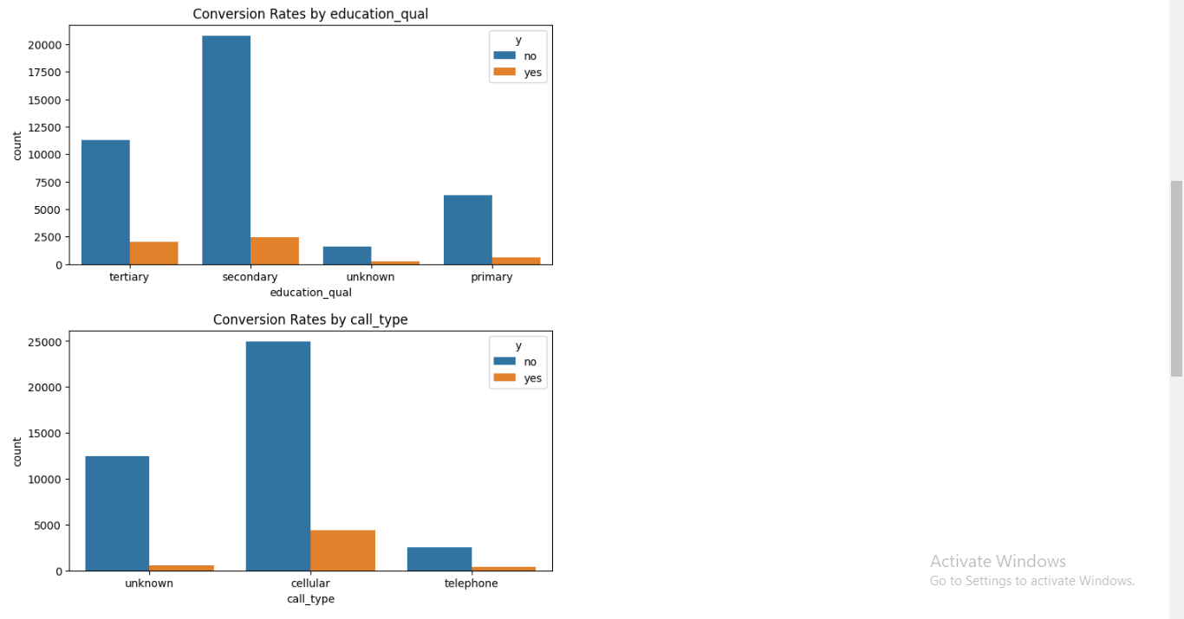
Figure 16: Conversion Rates by Education Qual and Call Type
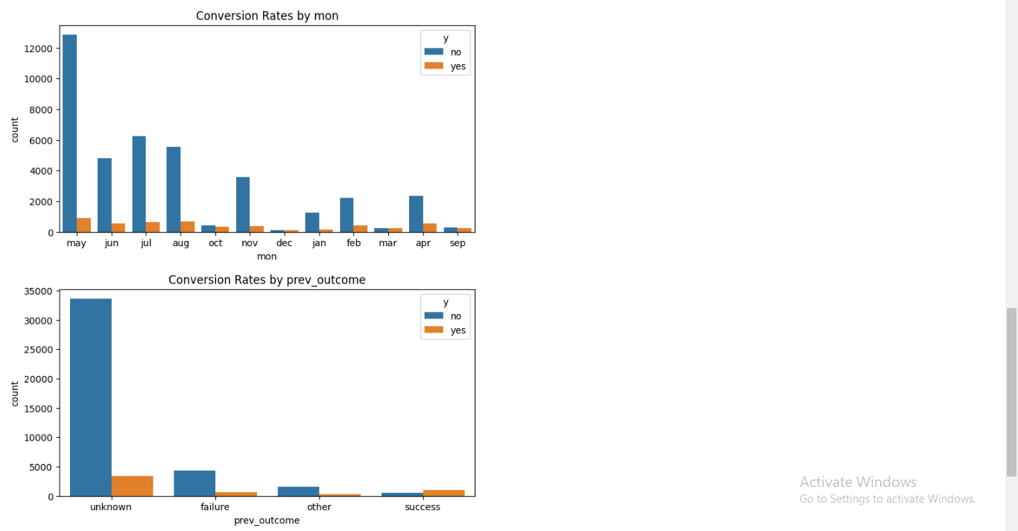
Figure 17: Conversion Rates by Mon and Prev Outcome
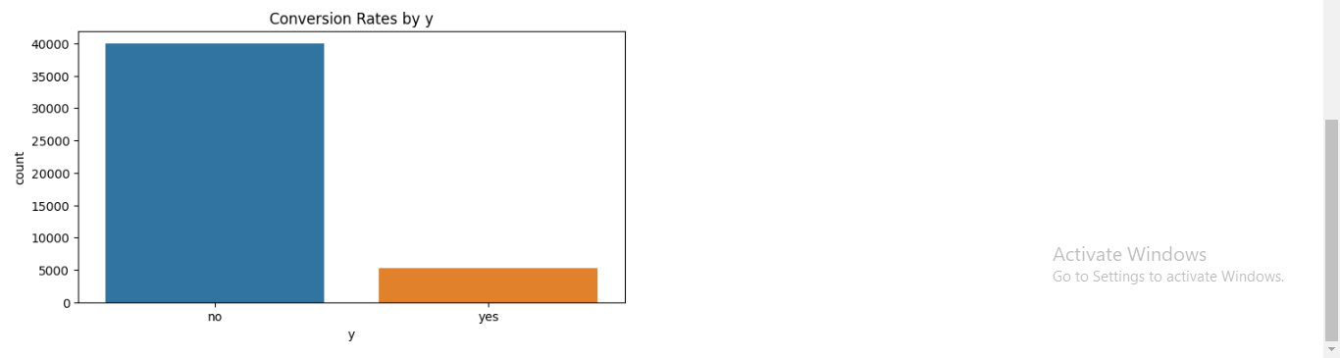
Figure 18: Conversion rates by Target Variable (y)

3. 3. 3 Insights from Visualizations
The visualizations highlighted several key insights:
- Customer Segmentation: There exists a difference in conversion rates depending on certain job fields and modes of contact implying the populations’ favorability towards marketing.
- Feature Importance: Call duration and previous outcomes have a closer correlation with conversion rates, thus making them relevant in the creation of predictive models.
These visual insights are useful as part of feature selection and in the building blocks for models in the next tasks.

CHAPTER THREE: MODEL SELECTION AND TRAINING

The following steps explain how customer conversion for term life insurance should be predicted by choosing the correct algorithm AI, preflight and formats, model tuning and learning, evaluation and relevance test (.), and finally, how Shmelova, T., Sikirda, Y., Rizun, N., Lazorenko, V. and Kharchenko, V., 2021) these data are split proportionally to the target variable..

4.1 Model Selection

4.1.1 Overview of Machine Learning Algorithms
A machine learning technique has been used to model total sales for term life insurance (Rawat, S., Rawat, A., Kumar, D. and Sabitha, A.S., 2021). At the same time, various algorithms have been used to predict customer conversion, all known as binary classification problems.
- This analysis is a type of statistical model that estimates the chances of two events and then tries to predict the binary outcomes as a result of the independent variables. It is easy to implement and understand, making it a good training technique, especially if the relationship between the features and target variable is linear.
- This training technique employs multiple decision trees to provide the most frequently used classification while handling problems allied to high dimensionality and big data, namely, multicollinearity. Compared to other models, it gives the variance and bias reduction and feature interaction capability.

The aim was to minimize those model performance measures and maximize the final algorithms' interpretability and predictiveness. At the same time, Random Forest is less interpretable than Lasso but capable of generating high-level models and processing feature interactions.

4.2 Data Splitting

4.2.1 Strategy for Data Splitting

When developing benchmark models, one must split the dataset into a training and test set. Also, the training set consists of data points that help find a suitable model, while the testing set checks how such a model performs over never-seen data. This is the best method of ensuring we see a model capable of performing how it was designed when exposed to other data on which it has yet to be trained. Generally, 80% of the datasets are used for training, while the remaining 20% is used for testing and validation.

4.2.2 Maintaining Target Variable Proportions (Stratification)
Stratified sampling is one of the model selection techniques in machine learning. In this technique, the distribution of the target variable in training and testing sets is aligned to ensure that the subset samples are not different from the total population. This approach minimizes bias from model training by assuring that the tested measures match the sample under evaluation since the algorithm cannot identify which sample it is working on.

4.2.3 Summary of Data Splitting Process
The data was then partitioned into training and testing datasets in an 80/20 ratio, and this was done to avoid the effects of class imbalance because the ‘Cancelled’ variable was a skewed class.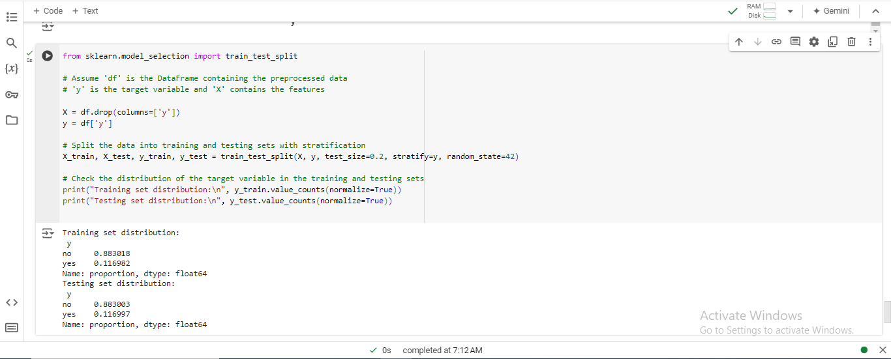
Figure 19: Jupyter Notebook Code and Output: Data Splitting and Class Distribution

The proposed data-splitting strategies help maintain the actuality of each class of the target variable, such as the actual class distribution in model training and testing datasets.

Summary of the Stratified Data Splitting Results:
- Training Set Distribution:
  - Class 'no': Approximately 88.3% of the observations.
  - Class 'yes': Approximately 11.7% of the observations.
- Testing Set Distribution:
  - Class 'no': Approximately 88.3% of the observations.
  - Class 'yes': Approximately 11.7% of the observations.

Using a stratified sampling strategy was appropriate in training and testing processes to minimize bias and improve the model's accuracy on unseen data, thus improving the overall evaluation (Wang, L., Han, M., Li, X., Zhang, N. and Cheng, H., 2021).

4.3 Model Training
Two models, Random Forest classifier and Logistic Regression classifier, will be used to train and test the training set to establish a sound customer conversion model.

4.3.1 Random Forest Model Training
The Random Forest algorithm is a method that uses multiple decision trees to improve prediction accuracy and reduce overfitting, making it particularly effective for classification tasks, ensuring stable and reliable model performance.
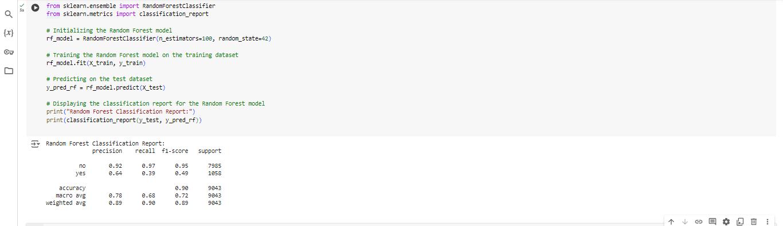
Figure 20: Jupyter Notebook Code and Output: Random Forest Model Evaluation

4.3.2 Logistic Regression Model Training
The Logistic Regression is a linear model that estimates probabilities using a logistic function. This is particularly useful when striving for model parsimony. It is frequently used for binary classification tasks because of its ease of interpretability and because the coefficients of the model give us an idea of the extent to which each feature in the model contributes to the final result.
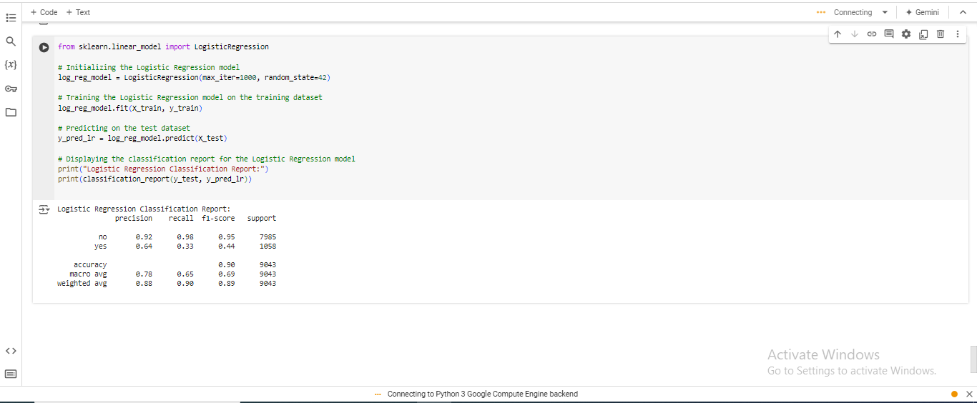
Figure 21: Jupyter Notebook Code and Output: Logistic Regression Model Evaluation

4.3.3 Summary of Model Training
This report assesses and compares random forest and logistic regression models trained in the paper. The Random Forest model is expected to yield high accuracy since it can analyze the independent non-linear relationships and suffers from overfitting. The logistic regression model makes interpretation likelihood for a model with linearity between predictors and target variables. The report mainly discusses model interpretation and model assessment.

CHAPTER FOUR: MODEL INTERPRETATION AND EVALUATION

This section analyses the prospect of applying machine learning models to predict customers’ conversion to term life insurance (de Lima Lemos, R.A., Silva, T.C. and Tabak, B.M., 2022). The paper seeks to understand the decision-making process and assess its efficiency through metrics concerning the reliability and suitability of the chosen model.

5.1 Model Interpretation

5.1.1 Feature Importance Analysis

Using the Random Forest algorithm, one can determine potential influencing factors of customer conversion, especially regarding selling term life insurance, including the interaction duration, number of dials made, and the customer's age. These research results are consistent with domain knowledge and focus on customer engagement measures' influences on sales results.

5.1.2 Explanation of Model Decision-Making Process

Random forest is one of the decision tree-based learning methods used in the insurance business to predict future customer behavior. Every tree has a bootstrapping test employing an independent data sampler. It recognizes the perpetual features while rendering choices to avoid overfitting the raw outcome and improve the crispness of the result.

5.1.3 Key Findings and Insights

It also focuses on customer touch points such as last contact and total calls to demonstrate how conversion probability can be influenced, meaning that customer touch points are critical determinants of conversion rates. It also emphasizes segmentation, emphasizing issues such as the age factor.

5.2 Model Evaluation

5.2.1 Evaluation Metrics (Accuracy, Precision, Recall, F1-score)
The performance of both Random Forest and Logistic Regression models was evaluated using standard classification metrics. Four parameters are considered for classification performance: accuracy, precision, recall, and F1-score.
- Random Forest Classification Report:
Table 3: Random Forest Classification Report
Metric | No | Yes
Precision | 0.92 | 0.64
Recall | 0.92 | 0.39
F1-Score | 0.95 | 0.49
Support | 7985 | 1058

- It was found that the Random Forest model had an accuracy of 90% for categorizing the non-converting customer, with a precision value of 92% and a recall value of 97% based on the ‘no’ class. However, the accuracy for the instance label ‘yes’ class was slightly low, with a precision of 64% and recall of 39%.
- Logistic Regression Classification Report:
Table 4: Logistic Regression Classification Report
Metric | No | Yes
Precision | 0.92 | 0.64
Recall | 0.98 | 0.33
F1-Score | 0.95 | 0.44
Support | 7985 | 1058

From the confusion matrix, it is found that the Logistic Regression model has 90% accuracy, 92% ‘no’ precision, and 98% ‘no’ recall but only a 33% ‘yes’ recall, meaning that it does not recognize converting customers as the Random Forest model does.

5.2.2 Hyperparameter Tuning and Optimization
The hyperparameter was then tuned using grid search cross-validation to improve the model's performance (Belete, D.M. and Huchaiah, M.D., 2022). Regarding the random forest, tree number, depth, and sample split were fine-tuned, and for the logistic regression model, the regularization strength and solver type were optimized.

5.2.3 Final Model Evaluation and Performance Summary
It was observed that hyperparameter tuning for both models marginally increased accuracy and recall. However, Random Forest more efficiently classified the ‘yes’ class. The current models remain slightly off when predicting converting customers and need more enhancement and feature engineering.

CONCLUDING REMARKS

6.1 Recap of Key Findings
The research applied the predictive model to identify potential term life insurance clients (Hossain, M.S. and Rahman, M.F., 2023) in HashSysTech Insurance Company while presenting an analysis.
- Data Exploration and Preparation: The data was well-preprocessed and cleaned, especially considering how to handle missing values, categorical variables, and encoding spells and outliers in the learning phase.
- Model Evaluation and Insights: Finally, the Random Forest model proved to be quite accurate and provided insights into significant factors, such as call duration and other prior campaign performances.

6.2 Recommendations
- Deploy Predictive Models: Market the products to the target customer by applying the Random Forest model, which is likely to target probable customers.
- Update Models Regularly: One must seek to feed the models with newer data as frequently as possible to ensure the models’ accuracy.
- Improve Data Collection: Improve the data quality for more features and better prediction values.
- Refine Engagement Strategies: Tracking aspects, such as the time customers spend on a call or how many follow-ups are made, can increase the conversion rate.
Final Thoughts: Predictive analysis using machine learning is crucial in insurance because it helps enhance strategies to reach the potential lie ideally (Qazi, M., Tollas, K., Kanchinadam, T., Bockhorst, J. and Fung, G., 2020). This approach is expected to become more or less normative in the industry, improving customer satisfaction and business benefits.

BIBLIOGRAPHY

Lemmens, A. and Gupta, S., 2020. Managing churn to maximize profits. Marketing Science, 39(5), pp.956-973.
Lavin, A., Gilligan-Lee, C.M., Visnjic, A., Ganju, S., Newman, D., Ganguly, S., Lange, D., Baydin, A.G., Sharma, A., Gibson, A. and Zheng, S., 2022. Technology readiness levels for machine learning systems. Nature Communications, 13(1), p.6039.
Lalwani, P., Mishra, M.K., Chadha, J.S. and Sethi, P., 2022. Customer churn prediction system:
a machine learning approach. Computing, 104(2), pp.271-294.
Gupta, P., 2021. Practical Data Science with Jupyter: Explore Data Cleaning, Pre-processing,
Data Wrangling, Feature Engineering and Machine Learning using Python and Jupyter (English Edition). Bpb Publications.
Elahe, M.F., Jin, M. and Zeng, P., 2021. Review of load data analytics using deep learning in smart
grids: Open load datasets, methodologies, and application challenges. International Journal of Energy Research, 45(10), pp.14274-14305.
Molin, S., 2021. Hands-On Data Analysis with Pandas: A Python data science handbook for data collection, wrangling, analysis, and visualization. Packt Publishing Ltd.
Magdum, R., 2022. What is Data Exploration? and its Importance in Data Analytics. Int. Res. J. Eng. Technol, 9(01), p.01.
Dallah, D. and Sulieman, H., 2022, August. Outlier Detection Using the Range Distribution. In International Conference on Recent Developments in Mathematics (pp. 687-697). Cham: Springer International Publishing.
Shmelova, T., Sikirda, Y., Rizun, N., Lazorenko, V. and Kharchenko, V., 2021. Machine learning and
text analysis in an artificial intelligent system for the training of air traffic controllers. In Research Anthology on Reliability and Safety in Aviation Systems, Spacecraft, and Air Transport (pp. 237-286). IGI Global.
Rawat, S., Rawat, A., Kumar, D. and Sabitha, A.S., 2021. Application of machine learning and
data visualization techniques for decision support in the insurance sector. International Journal of Information Management Data Insights, 1(2), p.100012.
Wang, L., Han, M., Li, X., Zhang, N. and Cheng, H., 2021. Review of classification methods on unbalanced data sets. Ieee Access, 9, pp.64606-64628.
de Lima Lemos, R.A., Silva, T.C. and Tabak, B.M., 2022. Propension to customer churn in a financial institution: A machine learning approach. Neural Computing and Applications, 34(14), pp.11751-11768.
Belete, D.M. and Huchaiah, M.D., 2022. Grid search in hyperparameter optimization of machine
learning models for prediction of HIV/AIDS test results. International Journal of Computers and Applications, 44(9), pp.875-886.
Hossain, M.S. and Rahman, M.F., 2023. Customer sentiment analysis and prediction of
insurance products’ reviews using machine learning approaches. FIIB Business Review, 12(4), pp.386-402.
Qazi, M., Tollas, K., Kanchinadam, T., Bockhorst, J. and Fung, G., 2020. Designing and
deploying insurance recommender systems using machine learning. Wiley Interdisciplinary Reviews: Data Mining and Knowledge Discovery, 10(4), p.e1363.

APPENDIX

Appendix A: Access to Python Code and Analysis
The Python code and data analysis used in this report can be accessed through the following Google Colab link: Colab Notebook: The forecast of HashSysTech Insurance’s Predictive Analysis.

